**Updating the Extension (For Telecommuting Staff):**

1. While at the office, go to the folder containing the C&S Connect Overlay extension

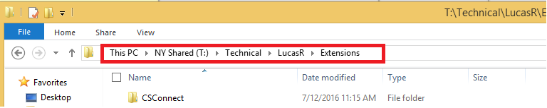

1. Copy the entire CSConnect folder
2. On your computer, go to where you placed the old version of the extension
3. Delete the old folder and Paste the new version in the same place
4. On Chrome, go to the Settings Page

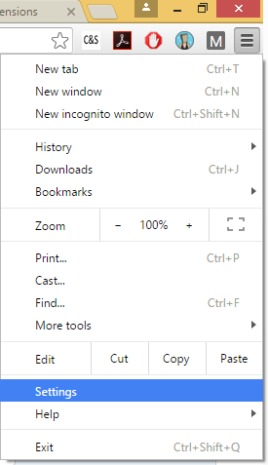

1. On the top left of the Settings Page, click “Extensions”

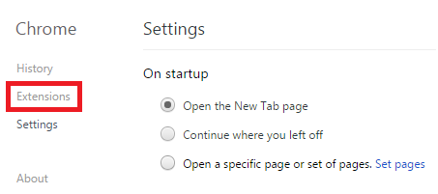

1. Click Reload next to the extension

